Form 1

Internship Notification Form

Date (YYYY/MM/DD)： / /

To:

Dean of the School of Design

Dean of the Graduate School of Design

[Student Information]

Department / Major:

Year / Student ID Number:

Name:

Mobile Phone Number:

[Supervisor]

Title / Name:

|  |  |  |  |
| --- | --- | --- | --- |
| Type of Activity | 1. During regular school hours   Course Title and Number of Credits: (　　　　　　　　　/ credits)   1. School events 2. Extra-curricular Activities | | |
| Period | YYYY/ MM / DD: / / - / / (Actual working days: 　 )  In-person Online  Hybrid (Both in-person and online)  ( Pre-training Yes No ･ Post-training Yes No ) | | |
| Place of Implementation | Company/ Institution name:  Department:  Location(Address):  *If overseas – Visa Type:  Visa Type:None Tourist Student Others( ) | | |
| Theme |  | | |
| Career development: Type of Support Activities  ※Refer to the reverse side. | Type 1:Open company  Type 2:Career education →Work experience Yes No  Type 3:General Skills / Specialized Skills Internship  Type 4:Highly specialized Internship | | |
| Allowance and Benefits Provided by the Company  /Institution | None Actual cost(Food expense, etc.)･Traveling expenses(Including accommodation) Wages･Reward Others( )  *Please check all applicable items regarding allowances provided by the company/ institution. | | |
| Name of Insurance Coverage Enrolled | Personal Accident Insurance for Students Pursuing Education and Research (PAS)”(Gakkensai)*Joining date (YYYY/MM/DD): / /  Liability Insurance coupled with PAS  *Joining date (YYYY/MM/DD): / / University CO-OP Student Life Insurance:  University CO-OP Student Personal Liability Insurance  Other ( 　　　　　 ) | | |
| ※事務記入欄 *Office use only | 協定等締結：　有・無 |

**Important Notes Regarding Internship Participation**

1. Students participating in internships must be enrolled in both the Personal Accident Insurance for Students Pursuing Education and Research (PAS/Gakkensai) and the Liability Insurance Supplementary to PAS.Supplementary to Gakkensai. In addition, please submit the Internship Notification Form. However, if you wish to be approved as credits, please refer to [INTERNSHIP](https://std.design.kyushu-u.ac.jp/education/Internship-credit-certification/).
2. Once the internship notification form is submitted to and accepted by the Dean of the Faculty or Graduate School, the internship will be considered officially approved and covered by the above-mentioned insurance policies.
3. Please submit the completed notification form to your student affairs office.

**Types of Support Activities**

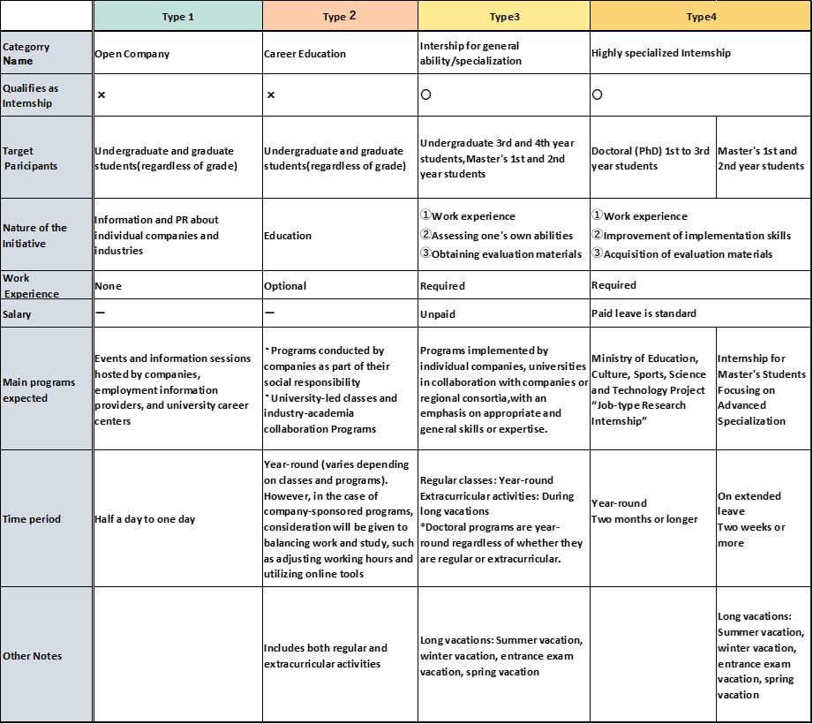

2025.6 revision

◆ Survey: How Did You Apply? ◆

Applied directly to the company

Through a job/internship search website

Through the university

Through an academic advisor

Other ( )